**Test Case 0005**

**System:** Bench

**Description:** Test to make sure that the timestamp is updated every time the user logs in and that the new data shows on the dashboard.

**Severity:** 3

**Instructions**

**Test1**

1. Start the Bench application.
2. Click the button “Login” on the navigation bar.
3. Enter the email “team23project@gmail.com” into the text field labeled “Email address”.
4. Enter the password “12345678” into the field labeled “Password”.
5. Click the button “Login” below the field.
6. After the screen has loaded, click on the button “My Profile” on the navigation bar.
7. Observe the profile page of the current user.

**Expected Result:** the last-login-data is shown on the “My Profile” page.

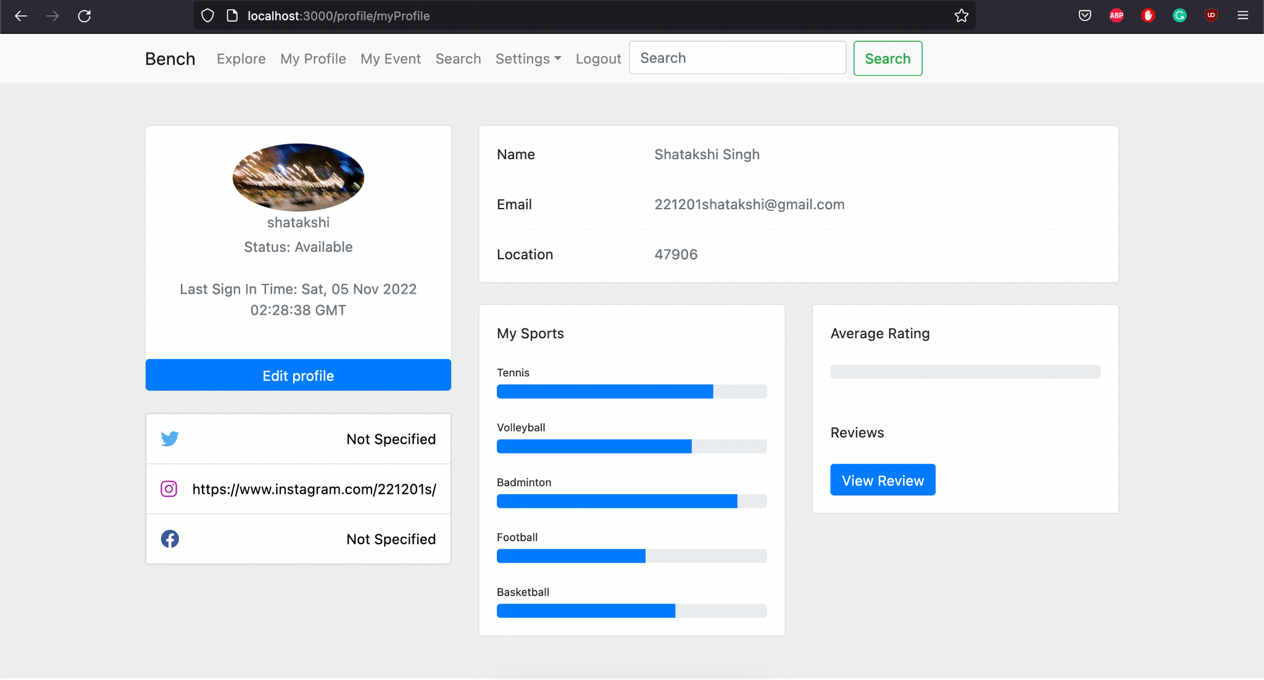

**Test2**

1. Start the Bench application.
2. Click the button “Login” on the navigation bar.
3. Enter the email “team23project@gmail.com” into the text field labeled “Email address”.
4. Enter the password “12345678” into the field labeled “Password”.
5. Click the button “Login” below the field.
6. After the screen has loaded, click on the button “My Profile” on the navigation bar.
7. Observe the profile page of the current user.

**Expected Result:** The last-login-data is shown immediately on the “My Profile” page.



**Test 3**

1. Start the Bench application.
2. Click the button “Login” on the navigation bar.
3. Enter the email “team23project@gmail.com” into the text field labeled “Email address”.
4. Enter the password “12345678” into the field labeled “Password”.
5. Click the button “Login” below the field.
6. After the screen has loaded, click on the button “My Profile” on the navigation bar.
7. Record the current last-login-data for the purpose of comparison.
8. Click the button “Logout” on the navigation bar.
9. The user should be redirected to the “Login” page.
10. Enter the email “joyjoyjoy@joy.com” into the text field labeled “Email address”.
11. Enter the password “joyjoyjoy” into the field labeled “Password”.
12. Click the button “Login” below the field.
13. Record the current time manually for the purpose of comparison.
14. After the screen has loaded, click on the button “My Profile” on the navigation bar.
15. Record the current last-login-data for the purpose of comparison.
16. Compare the first last-login-data, the second last-login-data, and the time recorded manually right when the user logged in.

**Expected Result:** the first and second last-login-data should be different. The second last-login-data should be nearly the same as the time recorded manually right when the user logged in, meaning that the data is updated each time the user logs in.



